Advertisement Phrases for CME Course

Social Media/Email

The FDA-led High Throughput Truthing (HTT) project [https://ncihub.cancer.gov/groups/eedapstudies/overview] created a 3.00 Credit Hour CME Course titled the Assessment of Stromal-Tumor Infiltrating Lymphocytes. Hosted on the FDA’s Continuing Education (CE) portal [https://ceportal.fda.gov/], the course introduces the clinical significance of stromal tumor-infiltrating lymphocytes (sTILs), gives an overview of how to perform and identify pitfalls in the sTILs assessment, and includes a manuscript by Salgado et al. (Annal Oncol., 2015) on TILs assessment recommendations by the International Immuno-Oncology Biomarker Working Group [www.tilsinbreastcancer.org].

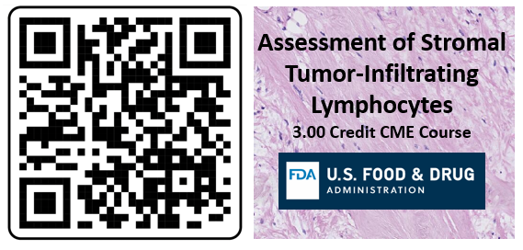

If we ever need to share instructions, will use some combination/variation of these:
To find the course: log into the portal - ceportal.fda.gov -- U.S. Food & Drug Administration-, click on “Online Learning”, and scroll down to our course. You can also use the search function in the “Online Learning” page to search for “Assessment”.

To find the course: log into the CE portal, click on “Online Learning”, and scroll down to our course. You can also use the search function in the “Online Learning” page to search for “Assessment”.

To find the course, create and account and log into the CE portal, click on “Online Learning”, and scroll down to our course. You can also use the search function in the “Online Learning” page to search for “Assessment”.

The course is approved for 3.00 CME credits.
Instructions for course access:
- Create an account in the FDA CE portal
- Click on “Online Learning” tab
- Scroll down to our course: “Assessment of Stromal Tumor-Infiltrating Lymphocytes”
  - You can also use the search function on the “Online Learning” page to search for “Assessment”.

